KARTEL AI
_______________________________________________
Enterprise Data Security &
Compliance Framework

Client Data Lifecycle: Ingest to Delivery
Two-Tier Training Security Model
Third-Party Vendor Compliance Analysis
Internal Platform Security Overview

CONFIDENTIAL
Kartel AI | 407 Maple Drive, Beverly Hills, CA
Draft v3.0 | February 2026

Kartel Platform Overview
Kartel operates two primary platforms that handle client data throughout the creative production lifecycle:
Platform | Description & Access
CIP  Creative Intelligence Platform | Client-facing and internal. Dashboard for asset intake, brief submission, deliverable review, and asset library. Clients interact exclusively through CIP Frontend.  Security: Independent client logins with authorized 2FA Google authentication. CIP does not store core client data unless explicitly authorized and submitted by the client. Clients are notified not to upload secure or RED CODE data through CIP, and should instead request a private S3 bucket for sensitive materials.
IPP  Internal Production Platform | Internal only. Production hub for project management, milestone tracking, artist/generative engineer workspace, and deliverable submission. Houses the Generation Platform (GP) for AI content creation.  Security: Independent logins with authorized 2FA Google authentication. Access limited to Kartel employees and vetted contractors only. All user activity tracked and logged.
Key principle: Clients only see the CIP Frontend. All internal production, generation, and training activity occurs behind CIP on internal systems.

Training Security Model: Two-Tier Classification
Kartel operates a two-tier training security model that provides appropriate protection based on data sensitivity. The tier is determined in consultation with the client during onboarding and formalized in the engagement contract.
 | Standard Secure Training | Air-Gapped / RED CODE Training
When Used | Default for most enterprise engagements. Client brand assets, product photography, creative materials. | Client-designated sensitive data. Recommended for: pre-production vehicles, unreleased products, embargoed campaigns, trade secrets.
Training Location | Local GPUs (primary). RunPod overflow GPUs when internal capacity is exceeded or dataset size requires additional compute. | Local GPUs ONLY. Air-gapped infrastructure at Beverly Hills facility. Network interfaces physically disabled. No internet connectivity.
Cloud Exposure | Source data may be uploaded to a secure S3 bucket and connected to RunPod for training. All SOC 2 compliant infrastructure. Client is notified and must approve. | ZERO cloud exposure. Source data never leaves the physical facility. Data transfer occurs only via encrypted physical media under chain-of-custody protocols.
Model Storage | Hugging Face private repository with 2FA and auth keys. Enterprise Hub available for SOC 2 audit trails and SSO. | Local storage only. Models remain on air-gapped infrastructure. Physical media transfer only under chain-of-custody.
Contract Clause | Option B: Secure Cloud Overflow Approved | Option A: Local-Only / Air-Gapped Training
RED CODE Classification: Data classified as RED CODE includes any material that the client designates as highly sensitive, including unreleased products, pre-production assets, embargoed campaigns, trade secrets, or any material where cloud exposure represents an unacceptable risk. RED CODE classification is determined during client onboarding and documented in the engagement contract.

Data Types in the Kartel Pipeline
Five distinct data types flow through the Kartel pipeline. Each has a different sensitivity profile, lifecycle, and security treatment:
Data Type | What It Is | Sensitivity | Lifecycle
Raw Training Data | Client brand assets, product photos, video, CAD files, creative materials | HIGH  Core proprietary client IP | Enters at Ingest. Consumed in Train. Destroyed per NIST 800-88 at Deliver.
LoRA Model | Safetensor file containing learned visual patterns. Cannot reconstruct source data. | MEDIUM  Derived IP, client-owned | Created at Train. Used in Generate. Stored for client at Deliver.
Generation Input | Prompts and parameters sent to third-party APIs via FAL | LOW  No client data, no brand assets, no PII | Created at Generate. Ephemeral — not retained.
Client Deliverables | Brand-accurate images, video, and creative assets produced by the engine | MEDIUM  Client-owned final output | Created at Generate. Sent to client at Deliver.
Performance Insights | Aggregated creative performance data from third-party vendors (e.g. VidMob). Distributed media metrics that inform content strategy. | LOW  Aggregated metrics, not core brand assets. Supplied by brand’s existing vendors. | Ingested at Generate to inform parameters. Feedback from Deliver loops back to Generate.

Client Data Lifecycle

1. Client Data Ingestion
Client data enters the Kartel pipeline through multiple secure channels, determined by client preference and data sensitivity classification.
Ingestion Method | Description | Security Controls
AWS S3 (Recommended) | Client uploads to a private S3 bucket provisioned by Kartel. Recommended for all HIGH sensitivity and RED CODE data. | SOC 2 / ISO 27001 compliant; AES-256 at rest; TLS 1.3 in transit; 2FA; bucket-level access controls
Physical Hard Drive | Client ships or hand-delivers encrypted drives to Beverly Hills office. | Chain-of-custody tracking from receipt; stored in locked physical safe; drive contents cataloged on intake
Google Drive | Client uploads to Kartel Google Drive or grants access to their own. | 2FA via Google Workspace; limited access permissions; client controls user access when sharing their own Drive
CIP Platform Upload | Client uploads directly through the CIP Frontend interface.  Note: CIP displays a notification advising clients not to upload secure or RED CODE data. Clients requiring secure data transfer should request a private S3 bucket. | 2FA authentication; gated access; secured via AWS Media Services DAM infrastructure
SharePoint / Dropbox / Other | Client provides access via their preferred file sharing platform. | Client-controlled access permissions; data downloaded locally upon receipt
Regardless of ingestion method, all client data is downloaded locally for processing. No client source data remains solely on third-party platforms during active engagement.

2. Client Data Storage
Once ingested, client data is stored in a controlled environment with strict access limitations.
Storage Location | What Is Stored | Security Measures
Internal NAS (Primary) | All client source data (images, video, brand assets, product photography) | Physically secured at Beverly Hills office; internal login only; access limited to assigned team members; fully protected network
Locked Physical Safe | Hard drives received from clients | Physical safe with restricted key holders; maintained at secure facility
AWS S3 (Intake/Delivery) | Intake bucket for S3-based transfers; private buckets for RED CODE data; delivery staging | SOC 2 / ISO 27001 compliant; 2FA; encrypted at rest; data moved to local NAS after transfer
CIP Platform (DAM) | Organized client assets within the Creative Intelligence Platform. Non-sensitive materials only unless client explicitly authorizes. | AWS Media Services infrastructure; 2FA; gated access; full access logging; notification that secure data should use S3

Core Storage Principles:
- Data Isolation: Each client’s data is siloed in separate NAS directories and S3 buckets. Client data is never commingled.
- Air-Gap Option: RED CODE data stored on air-gapped NAS with network interfaces physically disabled.
- Physical Security: 407 Maple Drive, Beverly Hills. Keycard + biometric access; 24/7 surveillance; locked server cabinets; visitor escort policy.

3. Client Data Access & Downloading
Access to client data is tightly controlled with the principle of least privilege applied throughout.
Control | Implementation | Monitoring
Personnel Vetting | Background verification, NDA with non-compete and IP assignment, completed before project assignment | HR records; annual re-verification
Least Privilege Access | Only team members assigned to specific client account have access to that client’s data | Access grants reviewed per project
Access Logging | All file access logged with timestamp, user ID, and action type on both CIP and IPP platforms | Real-time alerting on anomalous access patterns
Local Download Only | All data downloaded to internal NAS for training. No local copies on personal devices permitted. | Network monitoring; DLP controls
Physical Security | Keycard and biometric access; 24/7 surveillance; visitor logs; locked server cabinets | Security camera retention; access logs

Contractor Vetting & Onboarding Process
All contractors with access to the IPP platform go through a structured onboarding and vetting process:
- W-9 Verification: Identity and tax status confirmed
- IPP Profile Review: Portfolio and skills assessment
- NDA Execution: Non-disclosure with IP assignment clause
- Google Workspace Provisioning: 2FA-enforced account creation
- Project-Scoped IPP Access: Access limited to assigned projects only
- Activity Monitoring: All actions logged with same standards as employees
- Offboarding Revocation: Immediate access revocation upon project completion or termination

4. Custom Model Training
Kartel trains custom LoRA (Low-Rank Adaptation) models on client data. These models learn stylistic and structural patterns but cannot reconstruct original source assets. The training environment is governed by the Two-Tier Classification outlined above.

Training Infrastructure
Environment | Description | Security
Local GPUs (Primary) | On-premises GPU infrastructure at Beverly Hills office. Used for all RED CODE training and as primary for all standard training. | Air-gapped option available; network interfaces physically disabled for RED CODE; no internet during sensitive training
RunPod (Overflow) | External GPU rental for overflow capacity when internal GPUs are at capacity or dataset size requires additional compute.  NEVER used for RED CODE data. | SOC 2 Type II certified; Kartel 2FA secured account; data transferred via secure S3 bucket connection; client notified and must approve before use

How RunPod Is Used (When Approved)
- Internal GPU capacity reached or dataset requires more compute
- Client notified and provides written approval for cloud overflow
- Data transferred via encrypted S3 connection to RunPod instance
- Training executed on ephemeral instance (wiped on termination)
- Trained model (safetensor) extracted and stored on Hugging Face
- RunPod instance terminated; no residual data

Model Storage (Hugging Face)
Trained models produce a safetensor file, which is stored on Hugging Face:
- Private repository with authentication keys and 2FA
- Currently Pro plan; Enterprise Hub available for clients requiring SOC 2 audit trails and SSO
- Organization-level access controls limit who can view or download models
- RED CODE option: Local-only model storage, never uploaded to any cloud service
Key distinction: Trained models contain only learned parameters (stylistic patterns), not recoverable source imagery or data. The model cannot reconstruct original client assets. This is mathematically analogous to a human artist learning from reference: the knowledge is retained, not the source material.

5. Media Generation (IPP + FAL)
Content generation occurs within the Internal Production Platform (IPP), which integrates third-party AI generation APIs through a secure intermediary.

Critical Architecture Detail: Client Data Isolation in Generation
Client data does NOT pass through third-party generation APIs. The custom LoRA model trained on client data contains the client’s visual DNA. During generation, Kartel builds a custom workflow where prompts call the third-party API (e.g., Runway, Kling) to generate a base result, which is then processed through the client’s LoRA model locally. The prompts sent to third-party APIs do not contain client data, brand assets, or proprietary content. All client-specific intelligence lives exclusively in the custom model, which remains on Kartel’s infrastructure.

Component | Function | Security
IPP | Internal production platform where all client content creation and generations occur. Artists and generative engineers work here. | 2FA Google authentication; logged and gated access; Kartel employees and approved contractors only
FAL (API Gateway) | Enterprise-grade vendor providing API access to third-party generation models (Runway, Adobe Firefly, Kling, Wan, etc.)  Client data is NOT sent through FAL. Only generation prompts and parameters are transmitted. Client-specific intelligence is applied via local LoRA model after API response. | SOC 2 Type II compliant; private account with security authentication keys; all generations distributed directly into IPP; no client data exposure
Generation Platform (GP) | AI content generation engine embedded within IPP. Executes workflows, accesses LoRA models, creates assets. | Inherits IPP access controls; runs within IPP environment

Performance Insights in Generation
In addition to the core generation inputs (prompts + LoRA model), the generation step can be informed by a fifth data type: Performance Insights — aggregated creative performance data from third-party vendors (e.g. VidMob) that the brand already works with. This data informs generation parameters, enabling insight-driven content creation. See Section 7 for full detail on this data type, its lifecycle, and the feedback loop.

Generation Workflow
- Artist or generative engineer creates a generation brief in IPP
- Generation Platform loads the client’s trained LoRA model
- Performance insights (if available) are applied as generation parameters (see Section 7)
- Prompts and parameters sent to third-party model via FAL API
- Base result returned to IPP
- LoRA model applied locally to base output, producing brand-accurate result
- Result enters review/approval workflow in IPP

Generation Metadata & Audit Trail
Every generation created in the IPP captures comprehensive metadata:
- Timestamp, user ID, and project association
- Prompt text and parameters used
- Performance insight inputs applied (if any)
- LoRA model version referenced
- Third-party model and API endpoint used
- Output file hash and storage location

6. Asset Delivery & Output to Client
Deliverables are submitted to clients through their preferred method. All delivery channels maintain security and traceability.
Delivery Method | Description | Notes
CIP Platform (Recommended) | Client logs into CIP Frontend to review, approve, and download deliverables from their Asset Library | Full audit trail of views, downloads, and approvals. Most comprehensive tracking.
AWS S3 Delivery | Assets delivered to a secure S3 bucket for client pickup. Recommended for RED CODE deliverables. | SOC 2 compliant; encrypted transfer
Frame.io | Secure review and approval platform commonly used in media production | Industry-standard for creative review
WeTransfer / Figma | Secure third-party transfer platforms based on client preference | Encryption in transit; less comprehensive audit trail than CIP or S3
Google Drive | Shared folder delivery to client Google Workspace | 2FA; access controls
Delivery method is always determined by client preference. CIP Platform and AWS S3 provide the most comprehensive audit trails and are recommended for clients with elevated security requirements.

Performance Feedback Loop
Once deliverables are distributed by the client, performance data begins flowing back from the brand’s analytics vendors into the Generate phase, creating a continuous optimization loop. See Section 7 for full detail on the performance feedback cycle.
Data destruction note: Raw training data is destroyed per NIST 800-88 with written certification to client. The LoRA model is retained on Hugging Face (or locally for RED CODE) as client-owned IP and remains portable. Performance insights are retained as operational data to support the ongoing feedback loop.

7. Performance Insights & Feedback Loop
Performance Insights represent a fifth data type in the Kartel pipeline — distinct from the core creative asset lifecycle (Sections 1–6). This section covers what performance insights are, how they enter the pipeline, and how they create a continuous optimization loop that makes the creative engine adaptive.

What Are Performance Insights?
Performance Insights are aggregated creative performance metrics sourced from third-party vendors that the brand already works with. The primary example is VidMob, a creative intelligence platform that provides data on how distributed media (ads, social content, video) performs across channels. This data tells the generation engine what works for a specific brand’s audience, enabling customized, insight-driven content creation.
Examples of performance insight data include:
- Creative effectiveness scores by visual style, format, or messaging approach
- Engagement metrics by audience segment and channel
- A/B test results on creative variations
- Platform-specific performance benchmarks (Instagram, TikTok, YouTube, etc.)
- Trend data on emerging visual styles or content formats

Data Classification
Attribute | Performance Insights
Sensitivity Level | LOW  Aggregated performance metrics — not core brand assets, source imagery, or PII. Fundamentally different data class from raw training data.
Source | Third-party analytics vendors the brand already works with (e.g. VidMob, Meta Ads Manager, Google Analytics). Kartel does not collect this data independently.
Contains Client Data? | No core brand assets, no PII, no proprietary creative materials. Contains aggregated metrics about how creative content performs in market.
Retention | Retained as operational data to support the ongoing feedback loop. Not subject to NIST 800-88 destruction (not source data).

How Performance Insights Enter the Pipeline
Stage | What Happens | Security
Initial Ingestion (New Client) | When a new client’s creative intelligence engine is first built, historical performance data from the brand’s analytics vendor (e.g. VidMob) is ingested into the generation step. This data informs initial generation parameters — what visual styles, formats, and messaging approaches perform best for this brand. | Lower sensitivity: aggregated performance metrics, not core brand assets or PII.  Received via API integration or secure file transfer from the brand’s vendor.
Ongoing Feedback Loop | Once the creative engine is live and deliverables are being distributed, the brand’s media performance data flows back from the Deliver phase to the Generate phase. This creates a continuous optimization cycle: outputs perform → performance data captured → insights fed back → next generation refined. | Same low-sensitivity classification. Performance data is aggregated — it does not contain source creative assets.  Feedback loop is logged and auditable.

The Feedback Loop: Deliver → Generate
The performance feedback loop is what makes the creative engine adaptive, not just generative. It works as follows:
- Generate: Creative content is produced using the trained LoRA model + performance insight parameters
- Deliver: Approved assets are sent to the client and distributed across media channels
- Perform: Content runs in market across platforms (Instagram, TikTok, YouTube, programmatic, etc.)
- Measure: Brand’s analytics vendor (VidMob, etc.) captures creative performance data
- Feed Back: Performance data is ingested back into the Generate phase as updated insight parameters
- Refine: Next generation cycle uses updated insights to produce better-performing content
This cycle repeats continuously, with each round of content creating data that improves the next.

Key Principles
- Not core client data: Performance insights are aggregated media metrics (click rates, engagement scores, creative effectiveness data) — not brand assets, source imagery, or PII. They represent a fundamentally different and lower-sensitivity data class.
- Sourced from brand’s existing vendors: This data comes from third-party analytics platforms the brand already uses (e.g. VidMob, Meta Ads Manager data). Kartel does not collect this data independently.
- Actionable in generation: Once the brand’s creative intelligence engine is built (LoRA model trained), performance insights become parameters that guide what to generate — enabling hyper-targeted content that reflects real audience behavior.
- Creates competitive advantage: The Deliver → Generate feedback cycle is what differentiates Kartel’s creative engine from static AI generation tools. Each content cycle produces data that makes the engine smarter.

Worked Example
A CPG brand works with VidMob for creative intelligence. VidMob’s performance data shows that product-in-hand shots with warm lighting outperform flat-lay photography by 2.3x on Instagram for this brand’s audience. This insight is fed into the generation parameters, and the creative engine prioritizes that visual style for the next campaign batch. After the campaign runs, new performance data shows that the warm-lighting approach works even better when combined with close-crop framing. This updated insight is fed back, and the next generation cycle incorporates both parameters.

Visual Reference: Client Data Flow Diagram
A comprehensive interactive data flow diagram accompanies this document, visualizing how all five data types (Raw Training Data, LoRA Model, Generation Input, Client Deliverables, and Performance Insights) move through the six pipeline phases. The diagram includes security controls, vendor mapping, and the performance feedback loop.
Reference: kartel_data_flow.html
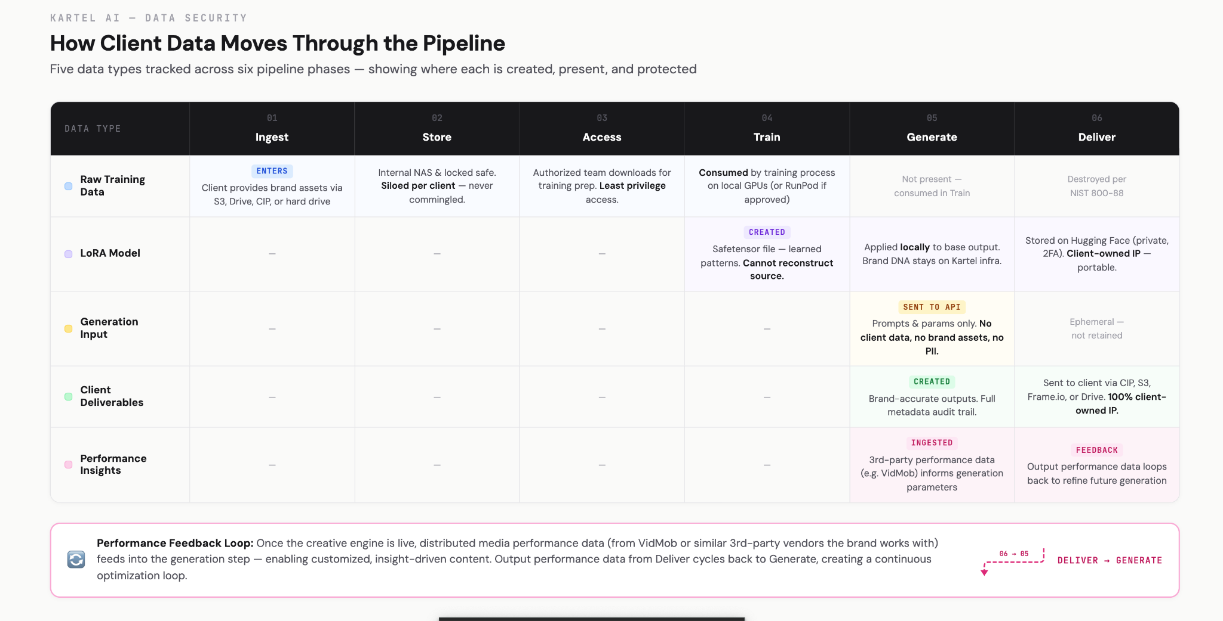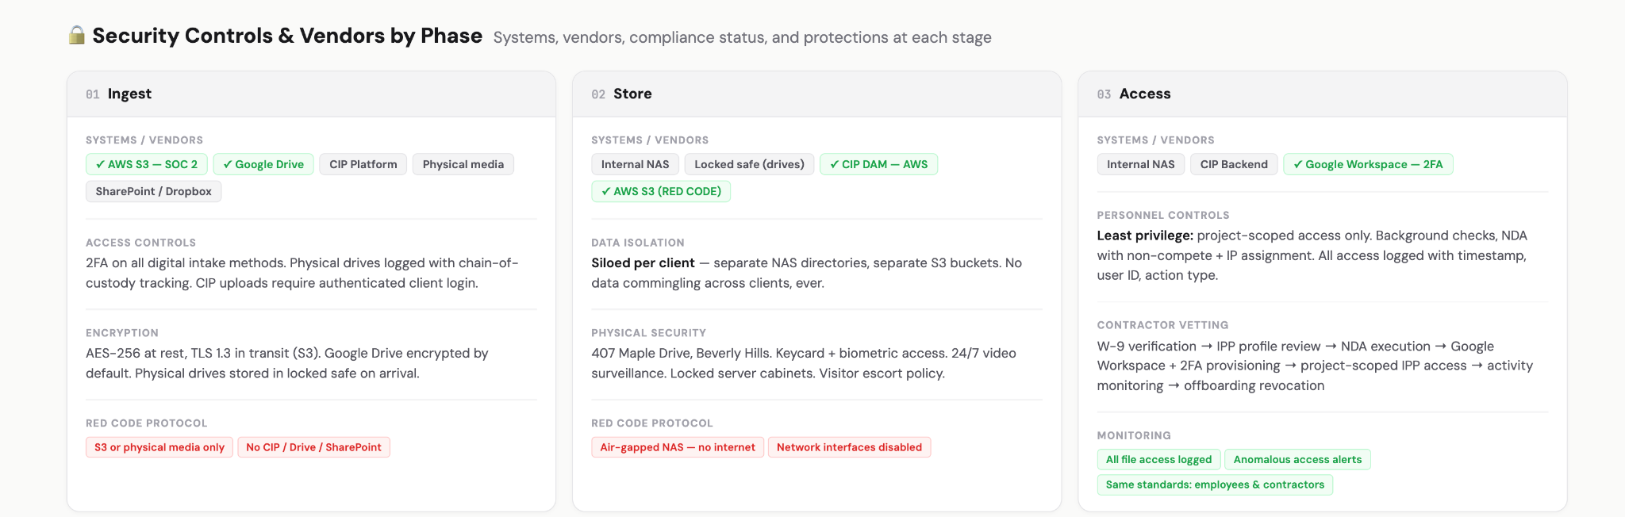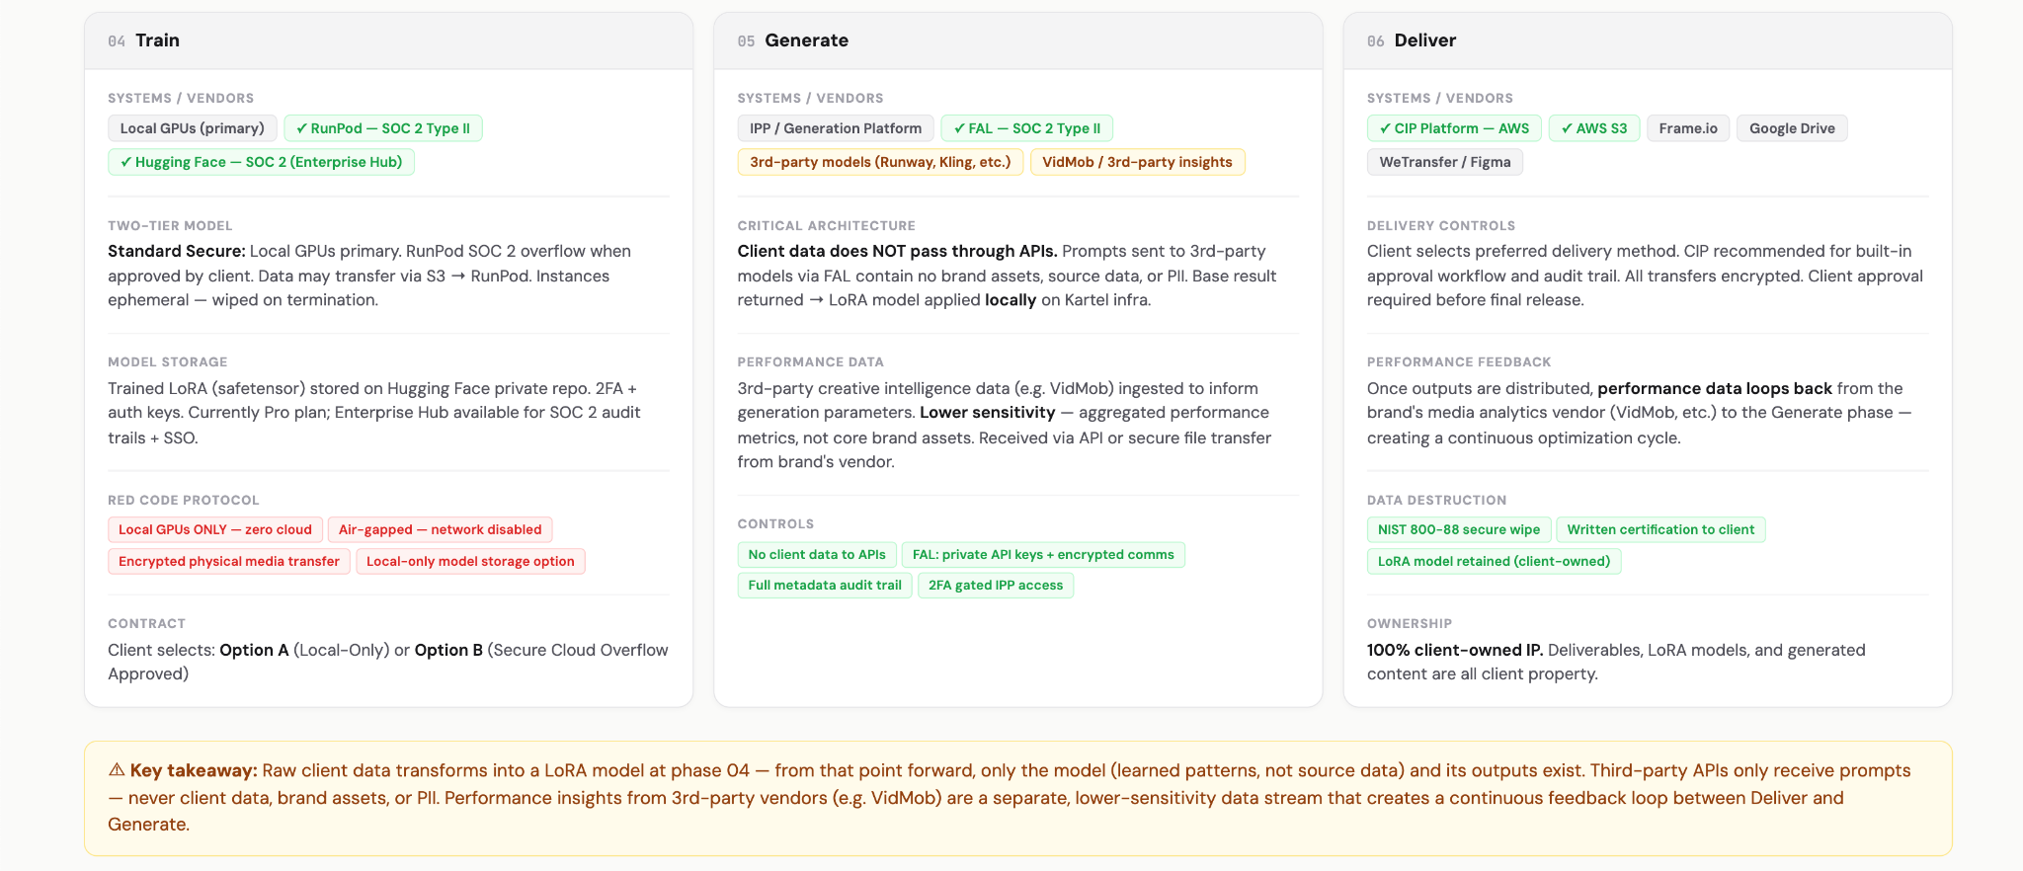

Third-Party Vendor Compliance Analysis
The following analysis covers the SOC 2 compliance status and security posture of each third-party vendor in the Kartel data pipeline. Compliance documentation links are provided for each vendor.

1. AWS (S3, Media Services, DAM Infrastructure)
SOC 2 Compliance | ✅ YES - SOC 2 Type II certified
Additional Certifications | ISO 27001, ISO 27017, ISO 27018, FedRAMP, HIPAA eligible, PCI DSS Level 1
Kartel Usage | CIP platform infrastructure (Media Services, DAM), S3 buckets for data ingestion and delivery, production inference environment
Key Security Features | AES-256 encryption at rest, TLS encryption in transit, IAM access controls, CloudTrail audit logging, VPC isolation
Risk Level | LOW - Gold standard for enterprise cloud infrastructure
Compliance Documentation | aws.amazon.com/compliance/soc-faqs/

2. RunPod (External GPU Training - Standard Tier Only)
SOC 2 Compliance | ✅ YES - SOC 2 Type II certified (achieved 2024)
Additional Certifications | GDPR compliant; pursuing additional certifications
Kartel Usage | Overflow GPU capacity for Standard Secure Training only. NEVER used for RED CODE / air-gapped data. Client must approve before use.
Key Security Features | Encrypted storage, private networking, secure API access, ephemeral instances (data wiped on termination)
Risk Level | MEDIUM - SOC 2 certified; requires client disclosure and written approval; never used for RED CODE
Compliance Documentation | runpod.io/blog/runpod-achieves-soc-2-type-ii-certification

3. FAL (AI API Gateway)
SOC 2 Compliance | ✅ YES - SOC 2 Type II certified
Additional Certifications | GDPR compliant; enterprise-grade SLAs available
Kartel Usage | API gateway for accessing third-party generation models (Runway, Adobe Firefly, Kling, Wan, etc.). Client data is NOT sent through FAL. Only generation prompts and parameters are transmitted.
Key Security Features | Private API keys, secure authentication, encrypted communications, no client data in transmission
Risk Level | LOW - SOC 2 certified; no client data exposure; prompts only
Compliance Documentation | trust.fal.ai

4. Hugging Face (Model Repository)
SOC 2 Compliance | ✅ YES - SOC 2 Type II certified (Enterprise Hub)
Additional Certifications | GDPR compliant; Enterprise Hub offers additional security controls, VPC options, and audit logs
Kartel Usage | Storage of trained custom LoRA models (safetensor files) in private repositories with authentication keys. Currently on Pro plan; Enterprise Hub available for clients requiring SOC 2 audit trails and SSO.
Key Security Features | Private repos, access tokens, 2FA, organization-level access controls. Enterprise Hub adds SSO, audit trails, and VPC.
Risk Level | LOW - Industry standard; models contain only learned parameters; Enterprise Hub upgrade available
Compliance Documentation | huggingface.co/docs/hub/en/security

5. VidMob (Creative Intelligence / Performance Data)
SOC 2 Compliance | ✅ YES - SOC 2 Type II certified
Additional Certifications | GDPR compliant; enterprise-grade security; works with Fortune 500 brands
Kartel Usage | Source of creative intelligence performance data that informs the generation engine. VidMob is the brand’s existing vendor — Kartel integrates with VidMob’s data output to create insight-driven content. Performance data only; no brand source assets flow through VidMob to Kartel.
Key Security Features | Enterprise API access, aggregated performance metrics only, no PII or brand source assets in data transfer
Risk Level | LOW - Aggregated performance metrics only; no core client data exposure; brand’s existing vendor relationship
Compliance Documentation | vidmob.com/security

Vendor Compliance Summary
Vendor | SOC 2 | GDPR | Risk | Data Exposed | Client Data?
AWS | ✅ Type II | ✅ Yes | Low | Infra, S3 | Yes (encrypted)
RunPod | ✅ Type II | ✅ Yes | Medium | Training data | Yes, Standard only
FAL | ✅ Type II | ✅ Yes | Low | Prompts only | No client data
Hugging Face | ✅ Type II | ✅ Yes | Low | Models only | No (learned params)
VidMob | ✅ Type II | ✅ Yes | Low | Perf. metrics | No (aggregated data)

End-to-End Data Flow Summary
The following outlines the complete data journey from client to deliverable, including the performance feedback loop. For a visual representation, refer to the companion kartel_data_flow.html diagram.
# | Phase | Action | Systems | Data Types Active | Security Layer
1 | Ingest | Client provides brand assets, product data, creative materials | S3 / Google Drive / CIP / Hard Drive / SharePoint | Raw Training Data | 2FA, chain-of-custody, encrypted transfer. RED CODE via S3 or physical.
2 | Store | Data organized and stored on internal infrastructure | Internal NAS, CIP DAM, AWS S3 | Raw Training Data | Air-gapped option, physical security, access logs, data isolation
3 | Access | Authorized team downloads data for training preparation | Internal NAS, CIP Backend, Google Workspace | Raw Training Data | Least privilege, personnel vetting, DLP, contractor vetting
4 | Train | Custom LoRA models trained; safetensor files stored | Local GPUs / RunPod (if approved); Hugging Face | Raw Training Data →  LoRA Model created | Two-tier model: air-gapped (RED CODE) or SOC 2 cloud (Standard)
5 | Generate | Content created using trained models + third-party APIs + performance insights. Client data stays in LoRA model, not in API calls. | IPP, Generation Platform, FAL APIs, VidMob (insights) | LoRA Model  Generation Input  Deliverables created  Performance Insights | 2FA, gated access, full metadata logging, no client data to APIs, performance data logged
6 | Deliver | Approved assets sent to client via preferred method. Performance data loops back to Generate. | CIP Frontend, S3, Frame.io, Google Drive | LoRA Model (stored)  Deliverables sent  Performance Feedback | Encrypted transfer, audit trail, client approval flow, NIST 800-88 destruction

Kartel Compliance Posture
The following outlines Kartel’s current compliance status and roadmap, distinguishing between vendor-level and Kartel organizational-level certifications.

Vendor-Level Compliance (Current)
All third-party vendors in the Kartel data pipeline maintain SOC 2 Type II certification: AWS, RunPod, FAL, Hugging Face, and VidMob.

Kartel Organizational Compliance
Framework | Status & Notes
AWS SOC 2 (Production Infra) | ✅ Active  Production infrastructure runs on AWS SOC 2 / ISO 27001 compliant services
NIST 800-88 (Data Destruction) | ✅ Active  Data destruction protocols with written client certification
GDPR | ✅ Active  Compliant processes in place
CCPA | ✅ Active  Compliant processes in place
Kartel SOC 2 (Organizational) | ⏳ 2026 Roadmap  Being assessed and pursued as part of Platform WhyGO #3. Timeline driven by enterprise client requirements.

Platform Security Controls (CIP & IPP)
While Kartel pursues organizational SOC 2 certification, both internal platforms maintain enterprise-grade security controls:
- 2FA Google Authentication on all user accounts (CIP and IPP)
- Independent login systems for clients (CIP) and internal team (IPP)
- Full activity logging on both platforms
- Role-based access control with project-scoped permissions
- Encrypted data transfer for all platform communications
- CIP notification system warning clients not to upload RED CODE data
Kartel’s position: The combination of SOC 2-certified vendor infrastructure, internal security controls (2FA, access logging, data isolation, physical security), and the two-tier training model provides enterprise-grade protection for client data. Organizational SOC 2 certification is being pursued on a timeline driven by client requirements.

Vendor Compliance Documentation Links
Vendor | Compliance Documentation URL
AWS | https://aws.amazon.com/compliance/soc-faqs/
RunPod | https://www.runpod.io/blog/runpod-achieves-soc-2-type-ii-certification
FAL | https://trust.fal.ai/
Hugging Face | https://huggingface.co/docs/hub/en/security
VidMob | https://www.vidmob.com/security

